SERLOCK TRAVEL · SOLO TRAVELER SAMPLE
Readiness Plan —
Lisbon

TRAVEL PREPARED. TRAVEL FURTHER.

SAFETY | HEALTH | SUPPORT | PEACE OF MIND
FICTIONAL SAMPLE · VERIFY ALL DETAILS BEFORE TRAVEL

Emergency Contacts
Service | Phone Number | Notes
All emergencies | 112 | Police, fire and ambulance throughout Portugal; give a precise location or nearby landmark.
Health advice line | SNS 24: 808 24 24 24 | Non-emergency clinical advice; call 112 for life-threatening symptoms (verify before travel).
Tourist police — Lisbon | +351 21 342 16 23 | Tourist support; verify opening hours and current number before travel.
U.S. Embassy Lisbon | +351 21 727 3300 | Consular assistance; confirm after-hours instructions on the official embassy website.
Hospital de Santa Maria | +351 21 780 5000 | Major public hospital switchboard; let 112 choose the emergency destination.
Hospital da Luz Lisboa | +351 21 710 4400 | Private hospital; confirm insurer network status and emergency access.
Home check-in contact | Maria — stored offline | Receives daily check-ins and starts the missed-contact procedure.

Nearest Hospital
Health advice line  SNS 24: 808 24 24 24  Non-emergency clinical advice; call 112 for life-threatening symptoms (verify before travel).  - Carry a one-page medical summary with diagnoses, allergies, medicines by generic name, insurer, and emergency contact.  - Use SNS 24 for stable concerns and 112 for severe or rapidly worsening symptoms; do not self-transport if faint, confused, or short of breath.  - Confirm the nearest suitable emergency department from the actual hotel and identify an insurer-approved private option (verify before travel).  24/7 EMERGENCY ACCESS · CONFIRM ROUTE | 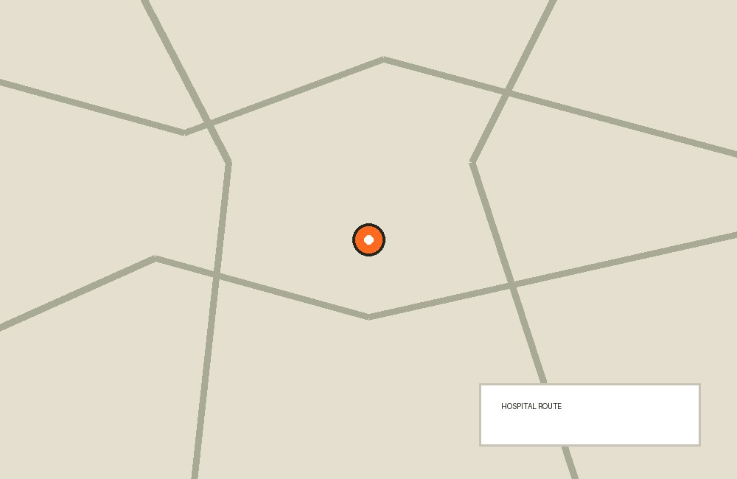

01 Destination Intelligence
Central Lisbon is walkable but hilly, with crowded transport corridors and highly variable pavement conditions.
- Review official Portugal travel advice, Lisbon civil-protection alerts, and the weather forecast 48 hours before departure and each morning.
- Secure phones and wallets at airport, metro, tram 28, Baixa, Alfama, and major viewpoints; keep bags closed and in front in crowds.
- Wear shoes with grip on polished calçada paving and use a taxi or metro when rain, fatigue, luggage, or steep streets make walking unsafe.
- Avoid demonstrations, isolated waterfront stretches after dark, and unsolicited help at ticket machines or ATMs.
- Save offline maps covering the hotel, two hospitals, the embassy, Lisbon Airport, Oriente, and Santa Apolónia stations.

02 Arrival & Late-Night Movement
The evening arrival is the first high-consequence period because no companion can confirm the driver, route, or room setup.
- Prebook a licensed transfer or use the official airport taxi queue; reject drivers soliciting inside the terminal.
- Send Maria the vehicle plate, driver name, departure time, and live location before leaving the airport.
- Keep the hotel address available on paper and offline; do not rely on a low-battery phone for navigation.
- Ask the driver to stop at the staffed hotel entrance and remain in the vehicle if the street or entrance appears closed.
- Complete a room and exit check before unpacking, then send the arrival check-in only after the door locks properly.

03 Accommodation-Specific Guidance
A centrally located staffed hotel supports solo-travel continuity if access, fire safety, and privacy controls are confirmed.
- Confirm 24-hour reception, the exact street entrance, after-hours access, and a staffed fallback if reception closes.
- Request a room away from an isolated ground-floor exit and verify the deadbolt, peephole, safe, smoke alarm, and two escape routes.
- Do not allow reception staff to announce the room number aloud; decline unexpected visitors and verify maintenance requests with the front desk.
- Store passport, reserve card, and emergency cash separately from the day bag, while keeping rapid access to essential medicine.
- Identify the closest staffed lobby, pharmacy, taxi pickup, and well-lit indoor waiting point before the first evening out.

04 Solo Check-In & Missed-Contact Protocol
A fixed cadence gives the home contact enough information to act without continuous tracking.
- Send check-ins after landing, hotel arrival, and by 21:00 local time daily, including the next planned movement.
- If a check-in is 30 minutes late, Maria sends WhatsApp and SMS, then calls twice over the next 30 minutes.
- At 60 minutes, Maria calls the hotel and checks the shared itinerary and last voluntarily shared location.
- At two hours without a credible explanation, Maria contacts local emergency services or the embassy using the saved trip details.
- Send an explicit safe message after itinerary changes so a late return is not mistaken for an emergency.

05 Itinerary Risk Notes
Crowded sights and day trips require deliberate timing, return plans, and a minimum battery reserve.
- Book timed entry for major attractions and travel outside peak commuter periods where practical.
- For Sintra, save the last reasonable return train and a licensed taxi fallback; do not begin an isolated trail late in the day.
- At viewpoints and waterfront areas, remain behind barriers and avoid cliff edges, wet rocks, and poorly lit shortcuts.
- Keep the phone above 40% before independent evening movement and carry a charged airline-compliant power bank.
- Leave a simple day plan with Maria, including destination, transport, expected return, and the time escalation should begin.

06 Emergency Protocols
The solo response sequence is: reach safety, call for help, transmit location, then notify the home contact.
- Call 112 for immediate danger, serious injury, chest pain, breathing difficulty, severe allergic reaction, collapse, or confusion.
- State “English, please,” give the address or landmark, explain that you are alone, and keep the line open.
- Move to a staffed public place after theft, harassment, or feeling followed; ask staff to call police rather than confronting anyone.
- Send a location pin and short status to Maria only after contacting emergency services when the situation is time-critical.
- Write incident times, names, report numbers, and treatment details when safe, preserving receipts for insurance.

07 Health & Medical Access
Independent travel requires early escalation because there is no companion to observe deterioration or communicate history.
- Carry a one-page medical summary with diagnoses, allergies, medicines by generic name, insurer, and emergency contact.
- Use SNS 24 for stable concerns and 112 for severe or rapidly worsening symptoms; do not self-transport if faint, confused, or short of breath.
- Confirm the nearest suitable emergency department from the actual hotel and identify an insurer-approved private option (verify before travel).
- Keep at least two days of essential medicine in the day bag and the remainder in cabin baggage, all in original packaging.
- Arrange a daily hydration, food, sleep, and medication check; seek assessment early if illness compromises safe solo movement.

08 Personal Security & Common Scams
Most foreseeable incidents are reduced by low-profile behavior and pre-decided responses.
- Use bank-affiliated ATMs inside staffed premises and cover the keypad; decline offers from strangers to “help” with cards or tickets.
- Ignore petitions, friendship-bracelet approaches, staged spills, and urgent demands for cash; step into a staffed business.
- Order rides in-app or through the hotel and verify the plate before entering; sit in the rear and share the trip.
- Carry only the payment cards and documents needed that day, with a small decoy amount of cash separate from reserves.
- If robbed, prioritize distance and safety over property, call police from a secure place, then freeze cards and devices.

09 Evacuation & Shelter-in-Place
Use the least complex safe option and avoid making major movement decisions without verified information.
- Leave by stairs during fire or visible smoke, take the grab pouch only if immediately accessible, and report to the hotel assembly point.
- Shelter away from windows during severe weather or nearby unrest, following hotel and civil-protection instructions.
- Use Lisbon Airport as the primary international departure point and Porto or an overland route only after confirming transport and border conditions.
- Contact the insurer assistance line before a non-immediate medical transfer; let treating clinicians determine transport suitability.
- Tell Maria the selected route, booking reference, departure point, and next check-in before any relocation.

10 Financial & Document Continuity
Separated backups allow recovery after one bag, card, phone, or passport is lost.
- Carry two payment cards from different networks, stored separately, plus a modest euro cash reserve.
- Store encrypted passport, insurance, booking, and prescription copies offline and with Maria.
- Record card-freeze numbers and device account recovery methods on paper without writing complete passwords.
- For passport loss, obtain a police report if required and follow official embassy replacement instructions.
- Keep an emergency budget for two extra hotel nights, replacement transport, medicine, and local calls.

11 Communications & Device Continuity
Connectivity must survive phone loss, weak data, and account lockout.* - Activate roaming or an eSIM before departure and test calls, SMS, maps, and the 112 emergency-call function. - Use a strong device passcode, enable remote lock and backup, and hide sensitive notification previews. - Carry Maria’s number, hotel details, insurer, and embassy information on a paper card. - Use hotel Wi-Fi only with current device security; avoid sensitive transactions on unknown public networks. - If the phone is lost, remotely lock it, revoke payment-wallet access, change critical passwords from a trusted device, and notify Maria. 12 Departure & Recovery *The plan remains active until arrival home and post-trip issues are closed.
- Check transport disruptions and airport terminal details the evening before departure and again before leaving the hotel.
- Use a hotel-arranged or licensed transfer with enough time for delays and accessibility needs.
- Send a departure check-in after security and a final arrival message after reaching home.
- Monitor for delayed illness and tell clinicians about recent Portugal travel when relevant.
- Archive reports and receipts, review what failed, and remove temporary location sharing after the trip.

12 Departure & Recovery
The plan remains active until arrival home and post-trip issues are closed.
- Check transport disruptions and airport terminal details the evening before departure and again before leaving the hotel.
- Use a hotel-arranged or licensed transfer with enough time for delays and accessibility needs.
- Send a departure check-in after security and a final arrival message after reaching home.
- Monitor for delayed illness and tell clinicians about recent Portugal travel when relevant.
- Archive reports and receipts, review what failed, and remove temporary location sharing after the trip.

Pre-departure Checklist
Documents & Essentials
☐ Confirm passport validity and Portugal entry requirements through official sources.
☐ Buy insurance covering disclosed conditions, treatment, evacuation, delay, and theft.
☐ Share flights, accommodation, day trips, and document copies securely with Maria.
☐ Separate passport copy, backup card, cash, and emergency phone list.
☐ Create a compact grab pouch with documents, medicine, charger, water, and warm layer.
☐ Practice the missed-phone, lost-passport, and medical-emergency sequence.
Health & Safety
☐ Confirm hotel address, 24-hour reception, exits, and nearest appropriate emergency department.
☐ Pack medicines in original labels with prescriptions and a two-day day-bag reserve.
☐ Verify hospital and tourist-police details before travel.
Travel Readiness
☐ Save 112, SNS 24, embassy, insurer, hotel, and Maria in the phone and on paper.
☐ Agree the 30-minute, 60-minute, and two-hour missed-check-in actions with Maria.
☐ Activate and test roaming or eSIM, offline maps, remote lock, and backups.
☐ Book the airport transfer and verify the pickup process.
☐ Download official alerts and check weather and transport 48 hours before departure.
☐ Record insurer assistance and claim numbers offline.
☐ Send the first test check-in before departure.
◇ Be informed. Be prepared. Travel with confidence.
This sample complements official advisories and insurance. Verify critical details before travel.
PRINT THIS PAGE · CUT AROUND THE OUTER LINE · FOLD AT CENTER
SERLOCK TRAVEL · QUICK REFERENCE  Lisbon  May 12–18 · Fictional sample · Solo traveler  EMERGENCY & SUPPORT  Emergency services  112  Health advice  SNS 24 · 808 24 24 24  U.S. Embassy  +351 21 727 3300  Public hospital  Hospital de Santa Maria · +351 21 780 5000  All details are fictional examples. Verify every number and route before travel. | TRIP DETAILS · CARRY OFFLINE  TRAVELERS  Alex Morgan · fictional traveler  ACCOMMODATION  Memmo Alfama Hotel · fictional booking  PERSONAL CONTACT  Write in: ______________________________  INSURANCE / ASSISTANCE  Provider: ______________________________  Policy: _________________________________  Phone: _________________________________  BEFORE CARRYING  Verify all phone numbers, addresses, coverage details and routes. This card complements official advisories and insurance.

