SERLOCK TRAVEL · FAMILY SAMPLE
Readiness Plan —
Barcelona

TRAVEL PREPARED. TRAVEL FURTHER.
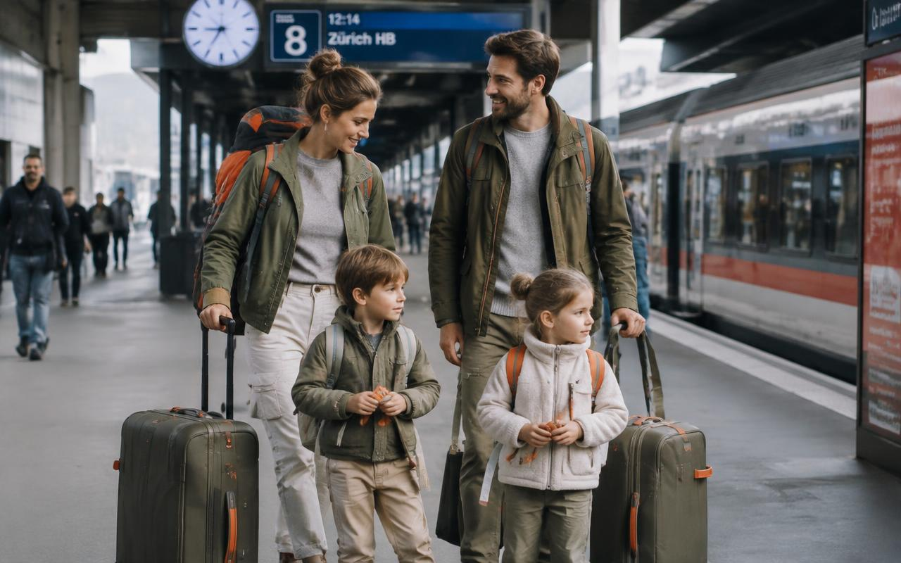
SAFETY | HEALTH | SUPPORT | PEACE OF MIND
FICTIONAL SAMPLE · VERIFY ALL DETAILS BEFORE TRAVEL

Emergency Contacts
Service | Phone Number | Notes
All emergencies: ambulance, police, fire | 112 | Free emergency number in Spain. Request English if needed; give the street address or landmark, patient age, and exact problem.
Catalonia medical advice and urgent health guidance | 061 | 061 Salut Respon can advise on care options. Use 112 immediately for anaphylaxis, severe breathing difficulty, serious injury, or immediate danger.
Barcelona municipal police | 092 | Guàrdia Urbana. Use 112 for a missing young child, an active threat, or an urgent police response.
Spanish National Police | 091 | Policía Nacional. Ask hotel staff which police station handles the relevant theft report; use 112 in an emergency.
U.S. Consulate General Barcelona | +34 93 280 22 27 | Passeig de la Reina Elisenda de Montcada, 23. Confirm American Citizen Services access and after-hours instructions through the official U.S. Embassy Spain website (verify before travel). Not a substitute for 112.
Major central adult hospital: Hospital Clínic Barcelona | +34 93 227 54 00 | Main switchboard; Villarroel campus, Carrer de Villarroel, 170. Confirm emergency entrance and whether this is the closest appropriate adult emergency department to your hotel (verify before travel). Call 112 rather than the switchboard for an emergency.
Pediatric emergency hospital: Hospital Sant Joan de Déu Barcelona | +34 93 253 21 00 | Main switchboard; Passeig de Sant Joan de Déu, 2, Esplugues de Llobregat. This is outside central Barcelona and is not necessarily the closest pediatric emergency department; confirm routing and current entrance (verify before travel). Let 112 select the destination in an emergency.
U.S. citizen assistance from overseas | +1 202 501 4444 | U.S. Department of State overseas assistance line. Confirm current availability and save the consulate’s after-hours instructions (verify before travel).

Nearest Hospital
Catalonia medical advice and urgent health guidance  061  061 Salut Respon can advise on care options. Use 112 immediately for anaphylaxis, severe breathing difficulty, serious injury, or immediate danger.  24/7 EMERGENCY ACCESS · CONFIRM ROUTE | 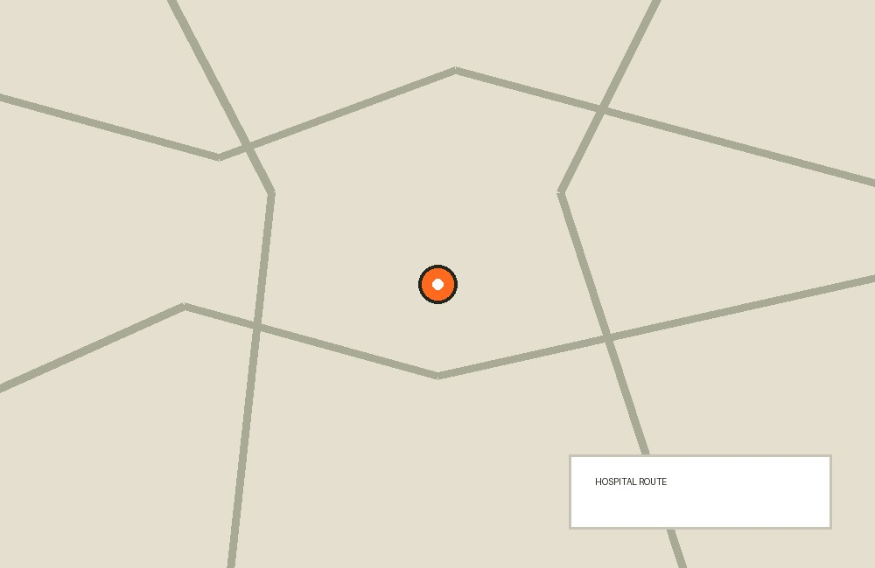

01 Destination Intelligence
Early November calls for rain-ready clothing, shorter sightseeing days, and flexible outdoor plans. Crowded tourist corridors and transport hubs require more attention to belongings than to confrontation.
- Check official weather forecasts and local alerts before departure and each morning; expect cool evenings, possible rain, and sunset around 17:40 rather than summer-length days (verify before travel).
- Keep passports, phones, and wallets secured in closed bags at Barcelona Sants, Plaça de Catalunya, La Rambla, and busy Metro stations; never leave a phone on a café table.
- Use quieter streets and daytime visits in the Gothic Quarter and El Born, and choose a taxi back if Rosa is tired or pavements are wet.
- Walk away from demonstrations, blocked streets, or confrontations; ask hotel staff for an alternative route rather than passing through a crowd.
- Enroll the family in the U.S. State Department’s STEP program and review the current Spain travel advisory, entry requirements, and any applicable European entry authorization requirements (verify before travel).

02 Accommodation-Specific Guidance
A city-centre hotel offers useful staff support, but the precise building, street, and accessibility remain unknown. Treat the hotel reception desk as the family’s base and obtain property-specific safety information on arrival.
- Ask for step-free entry, a reliable lift, a walk-in shower, a nonslip bathroom surface, and rooms near one another; confirm each feature directly rather than relying on an accessibility label (verify before travel).
- Request the hotel’s full address, reception telephone number, nearest taxi pickup point, and a printed location card for every traveler.
- Walk the escape route with Ana and Luis on arrival, identify a second stair route if available, and ask how staff assist guests with reduced mobility during an evacuation.
- Ask reception to explain accessible emergency alerts for Rosa’s hearing loss and designate Ana or Luis to wake and guide her if an alarm occurs.
- Ask breakfast staff about peanut ingredients and cross-contact before Mia eats; keep safe backup food in the room and secure medicines away from children without delaying adult access.

03 Itinerary Risk Notes
Keep the arrival evening simple and build Days 2–6 around one main attraction each day. Park Güell needs particular planning for slopes and crowds; beach visits should be shore-based in November.
- Resolve the departure-date mismatch before booking transfers: 2 November is Day 1, 8 November is Day 7, and 9 November is Day 8 (verify before travel).
- Use an official airport taxi rank or a reputable prebooked transfer on arrival evening; reserve appropriate child restraints and enough space for five passengers, luggage, and Rosa’s cane (verify before travel).
- Book Park Güell directly for a quieter available entry period, confirm its recommended accessible entrance and route, and use a taxi to the suitable entrance rather than committing Rosa to an uphill approach (verify before travel).
- Book Sagrada Família admission directly, confirm accessible entry and security arrangements, and avoid tower visits if stairs, enclosed spaces, or balance demands are unsuitable for Rosa (verify before travel).
- Keep Mia and Leo out of the sea at Barceloneta on this November trip; seasonal lifeguard coverage may be limited, and flags or calm-looking water do not establish that swimming is safe (verify before travel).
- Stay back from breaking waves, wet breakwaters, and storm-exposed promenades; if someone is swept away, call 112, point continuously to their location, and throw flotation if available rather than entering the water.

04 Emergency Protocols
Use 112 for time-critical illness, injury, fire, or a missing young child. Prioritize treatment and a clear location over contacting insurers or finding a preferred hospital.
- Call 112 and say, “English, please. We are at \[address or landmark\]. A \[age\]-year-old has \[problem\].” State the nearest entrance, current symptoms, and callback number.
- Start Mia’s prescribed anaphylaxis treatment immediately when indicated, then call 112; describe the event as suspected anaphylaxis and give the time of each epinephrine dose.
- Give Leo his prescribed rescue inhaler according to his written asthma action plan; call 112 for severe breathing difficulty, inability to speak normally, blue or grey lips, marked drowsiness, or poor response.
- Seek urgent emergency assessment after any head strike involving Rosa because she takes a blood thinner, even if she initially feels well; call 112 for significant impact, symptoms, collapse, or unsafe transport.
- Have Luis provide medicines and medical details while Ana calls, shares the location, and directs responders; keep the unaffected children with a responsible adult rather than sending them ahead.
- Request an interpreter if needed and retain discharge papers, prescriptions, and receipts; notify the insurer after urgent care has started, not before.

05 Evacuation & Shelter-in-Place
Follow official instructions during severe weather, a building incident, or transport disruption. Rosa’s mobility and the children’s medicines should shape the response without delaying escape from immediate danger.
- Leave immediately by the designated stairs during a fire alarm or visible smoke; do not use ordinary lifts or return for bags.
- Ask the hotel in advance for its assisted-evacuation procedure for Rosa; if stairs cannot be used safely, report her exact location to 112 and hotel staff and follow their instructions rather than attempting an unsafe carry.
- Shelter indoors during severe coastal weather or nearby unrest, move away from windows when advised, and avoid basement areas or routes threatened by flooding.
- Keep an accessible grab bag with essential medicines, phone power, identification copies, water, safe snacks, and warm layers; take it only if immediately reachable.
- Use a hotel-arranged vehicle for a nonurgent relocation and confirm road or rail conditions before heading to Barcelona Sants or Barcelona–El Prat Airport; arrange medical evacuation only through treating clinicians and the insurer.

06 Financial & Document Continuity
Ana leads documents and money, but Luis needs independent access to essentials. Separate backups prevent one lost bag or phone from disabling the whole family.
- Keep passports secured when not required, carry useful identification copies separately, and confirm current Spanish identification requirements and carrier document rules (verify before travel).
- Store encrypted digital copies of passports, bookings, insurance, prescriptions, and emergency contacts; give Luis offline access and carry one paper set separately.
- Split payment cards and a modest euro cash reserve between Ana and Luis; keep backup cards apart from the main wallet.
- Buy insurance that explicitly covers Mia’s allergy, Leo’s asthma, Rosa’s anticoagulant use and any underlying condition, emergency treatment, evacuation, and an accompanying caregiver (verify before travel).
- For theft, freeze affected cards, obtain a police report when appropriate, and contact the U.S. consulate for passport replacement instructions; do not assume U.S. health coverage or Medicare will pay Spanish medical bills.

07 Communications Plan
Both adults need independent connectivity, and Leo’s watch phone is a backup rather than a tracking guarantee. Rosa’s hearing loss makes written and face-to-face communication important.
- Enable roaming or a suitable local data plan on both adults’ phones and test voice calls; confirm whether Leo’s watch supports international service, location sharing, and calls without his paired phone nearby (verify before travel).
- Save Ana’s and Luis’s numbers in +1 international format on Leo’s watch and all ID cards, and add the hotel’s +34 number once confirmed.
- Download offline Barcelona maps and save hotel, hospital, attraction, and meetup pins; carry charged power banks in compliance with airline rules (verify before travel).
- Send a morning itinerary and evening check-in to a trusted U.S. contact, using Barcelona local time; ask that contact to try both adults and the hotel before escalating an unexplained missed check-in.
- Use SMS or voice calls if mobile data fails, and show Rosa written changes while facing her clearly; do not rely on shouted instructions or a watch notification in a crowd.

08 Family Roles & Responsibilities
Ana leads documents, money, and communications; Luis leads medicines and active child supervision. Rosa may stay beside Mia for companionship, but she should not be the sole safety backstop in crowds or emergencies.
- Assign Ana primary responsibility for passports, insurance, payments, emergency calls, and navigation; have Luis carry copies, a separate payment card, and the hotel details.
- Assign Luis primary responsibility for Mia’s two EpiPen Jr devices, Leo’s Ventolin and spacer, and both children’s written action plans; train Ana to locate and use every item.
- Keep Luis responsible for Mia and Leo during walking and transport, with Ana counting all five travelers at every doorway, boarding point, and exit.
- Pair Rosa beside Mia when conditions allow, but have Ana or Luis remain close enough to supervise and intervene; never require Rosa to chase a child or manage a moving crowd.
- Use an explicit handover—“Ana, you have Mia and Leo”—and obtain a spoken acknowledgment before either adult leaves; if a child needs hospital care, send one adult with the patient and keep the other with Rosa and the sibling.

09 Lost-Child & Separation Protocol
Mia and Leo should stop, seek identifiable help, and never try to travel to a distant meetup alone. A missing young child warrants an immediate alert, not a 15-minute waiting period.
- Teach Mia: “Stop where it is safe. Find a uniformed police officer or a staffed counter. Say: ‘I am lost. Please call my mum.’” Teach Leo the same steps and have him call Ana on his watch, then Luis if Ana does not answer.
- Rehearse the Spanish script, “Estoy perdido/perdida. Llame a mi mamá, por favor,” and instruct both children not to leave the public area with someone offering help or go looking for the family.
- Give each child a discreet ID card with first name, both adult numbers, hotel details, and essential medical information; add Mia’s peanut allergy and Leo’s asthma, but keep room numbers and the code word off the card.
- Keep “pineapple” private and use it only as an extra check for a family-arranged pickup; tell the children it never overrides the need to confirm directly with Ana or Luis and is not required to accept help from identifiable police or staff.
- In minutes 0–5, have Luis stay at the last-seen point with the other child and Rosa while Ana alerts venue security and calls 112 immediately for a missing child; provide age, clothing, photo, medical needs, and watch location if available.
- In minutes 5–15, follow police instructions, keep one adult reachable at the last-seen point, and have staff check exits and nearby facilities; do not leave the area for the hotel or send Rosa searching.

10 Family Meetup Locations
Use visible, named meeting points for adult coordination, not as destinations that separated children must reach alone. Confirm each exact spot in person and save a photo and pin.
- Set the primary hotel meetup at the reception desk inside the accommodation; ask reception for a separate outdoor assembly point if the building is evacuated (verify before travel).
- Choose a near-hotel backup only after the address is known; if the hotel is near Plaça de Catalunya, consider the main public entrance of El Corte Inglés on the square, with the precise doorway and hours confirmed (verify before travel).
- At Sagrada Família, use the lake-facing side of Plaça de Gaudí opposite the basilica as the area meetup; select and photograph one specific bench or fixed feature on arrival (verify before travel).
- At Park Güell, choose the staffed entrance actually used for your booking as the area meetup and photograph its name; confirm accessibility, staffing, and re-entry restrictions before entering (verify before travel).
- At Barceloneta, use the exterior entrance of Centre de la Platja beneath the arcades on Passeig Marítim de la Barceloneta as a landmark, not a promise of open facilities; confirm the entrance and choose an indoor alternative in poor weather (verify before travel).
- At Barcelona Sants or the airport, identify a specific staffed information point after arrival; stay within the same security or ticketed zone unless staff direct otherwise.

11 Pediatric Allergies, Medications & Care
Mia’s severe peanut allergy and Leo’s asthma require written, clinician-approved plans and immediately accessible supplies. Hospital Sant Joan de Déu is a specialist pediatric option, but emergency dispatch should choose the appropriate receiving hospital.
- Confirm Mia’s current weight and prescribed device with her clinician: EpiPen Jr delivers 0.15 mg and its U.S. labeling covers 15–30 kg, which includes her reported 21 kg (verify before travel). Carry both devices together in Luis’s accessible day bag, check expiry and solution appearance, and follow the prescribed action plan.
- For suspected anaphylaxis, use the prescribed auto-injector promptly in the outer mid-thigh and call 112; if symptoms persist after 5 minutes, use the second device according to her action plan or dispatcher guidance. Keep Mia lying flat unless breathing difficulty requires sitting with legs extended, and do not let her stand or walk.
- Have Leo’s clinician write his exact Ventolin strength, number of puffs, spacer technique, repeat interval, and emergency escalation steps; do not infer a dose from the brand name alone (verify before travel). Carry the inhaler and spacer together and confirm sufficient remaining doses.
- Show restaurants: “Mi hija tiene una alergia grave al cacahuete. Puede sufrir anafilaxia. ¿Contiene cacahuete, aceite de cacahuete o puede haber contaminación cruzada?” Use the Catalan phrase “La meva filla té una al·lèrgia greu als cacauets,” and decline food when staff cannot confirm safe preparation.
- Avoid relying on visual inspection, buffet labels, or removing peanuts from a dish; check packaged-food warnings and bring safe snacks for flights, queues, and delayed meals.
- Ask reception to identify the closest pediatric-capable emergency department and a nearby pharmacy, plus the official duty-pharmacy listing through the Barcelona pharmacists’ association (verify before travel). Carry original packaging and prescriptions, and do not assume a U.S. prescription can be filled directly or that a pharmacy can replace emergency care.

12 Elderly Traveler Considerations
Rosa’s cane, mild hearing loss, and blood thinner use call for fall prevention and generous pacing. November heat is less prominent than summer heat, but dehydration and overdressing still deserve attention.
- List Rosa’s anticoagulant name, dose, indication, usual dosing time, prescriber, and any monitoring requirements; have her clinician map the schedule across time zones and advise on missed doses without doubling them (verify before travel).
- Plan a seated break every 45–60 minutes, schedule toilets and meals before long queues, and offer Rosa a shorter alternative or hotel rest period without separating her from adult support.
- Use grippy shoes, inspect the cane tip, avoid wet paving and steep shortcuts, and choose step-free attraction routes; consider a prearranged mobility aid if her usual walking tolerance is insufficient.
- Prefer taxis when tired or during rain, and confirm vehicle entry height and assistance; check TMB lift availability before Metro journeys because an accessible station on a map may have a lift outage (verify before travel).
- Carry water and layered clothing, avoid prolonged exposure in unexpectedly warm sun, and speak face-to-face in quieter places; pack spare hearing-aid batteries or a charger if she uses hearing aids.
- Avoid starting ibuprofen, aspirin, or other nonprescribed medicines without checking interactions with her anticoagulant; seek urgent help for unusual bleeding, black stools, sudden severe headache, weakness, or any concerning fall.

Pre-departure Checklist
Documents & Essentials
☐ Confirm whether the departure date is 8 or 9 November and align hotel nights, tickets, and transfers (verify before travel).
☐ Check passport validity, Spanish entry conditions, and any applicable European entry authorization requirements through official sources (verify before travel).
☐ Enroll in STEP and save current consulate and emergency contact details offline (verify before travel).
☐ Purchase travel insurance covering the disclosed medical conditions, emergency care, evacuation, and caregiver arrangements (verify before travel).
☐ Prepare bilingual allergy cards, discreet child ID cards, and recent photos of Mia and Leo.
☐ Download offline maps and documents, split cards and cash, charge power banks, and review weather and transport alerts before departure.
Health & Safety
☐ Obtain Mia’s updated allergy action plan and confirm that her 0.15 mg EpiPen Jr prescription remains appropriate for her current weight (verify before travel).
☐ Obtain Leo’s written asthma plan with exact Ventolin dosing, and pack his spacer and adequate medication supply (verify before travel).
☐ Obtain Rosa’s medication list, time-zone dosing schedule, interaction advice, and any anticoagulant monitoring plan (verify before travel).
☐ Pack medicines in original labeled packaging in cabin baggage, with prescriptions, clinician letters, and a reasonable delay allowance.
☐ Confirm the nearest suitable adult and pediatric emergency departments, pharmacy, and exact meetup landmarks once the hotel is known (verify before travel).
Travel Readiness
☐ Provide the hotel name and street address, and confirm step-free entry, lift, bathroom setup, and assisted evacuation arrangements (verify before travel).
☐ Check both of Mia’s auto-injectors for expiry and condition, and rehearse their use with a trainer device.
☐ Rehearse the stop-and-seek-help rule, both adult phone numbers, and the limited purpose of the code word “pineapple.”
☐ Test Leo’s watch-phone roaming, independent calling, location sharing, battery life, and adult access (verify before travel).
☐ Book accessible attraction arrangements and a five-person airport transfer with appropriate child restraints (verify before travel).
◇ Be informed. Be prepared. Travel with confidence.
This sample complements official advisories and insurance. Verify critical details before travel.
PRINT THIS PAGE · CUT AROUND THE OUTER LINE · FOLD AT CENTER
SERLOCK TRAVEL · QUICK REFERENCE  Barcelona  June 8–16 · Fictional sample · Family travelers  EMERGENCY & SUPPORT  Emergency services  112  Medical advice  061 Salut Respon  U.S. consular help  Verify current official number  Adult hospital  Hospital Clínic Barcelona · verify entrance  Pediatric hospital  Sant Joan de Déu · verify route  All details are fictional examples. Verify every number and route before travel. | TRIP DETAILS · CARRY OFFLINE  TRAVELERS  The Rivera family · fictional travelers  ACCOMMODATION  Central Barcelona apartment · fictional booking  PERSONAL CONTACT  Write in: ______________________________  INSURANCE / ASSISTANCE  Provider: ______________________________  Policy: _________________________________  Phone: _________________________________  BEFORE CARRYING  Verify all phone numbers, addresses, coverage details and routes. This card complements official advisories and insurance.

