SERLOCK TRAVEL · CLINICIAN SAMPLE
Readiness Plan —
Uganda

TRAVEL PREPARED. TRAVEL FURTHER.
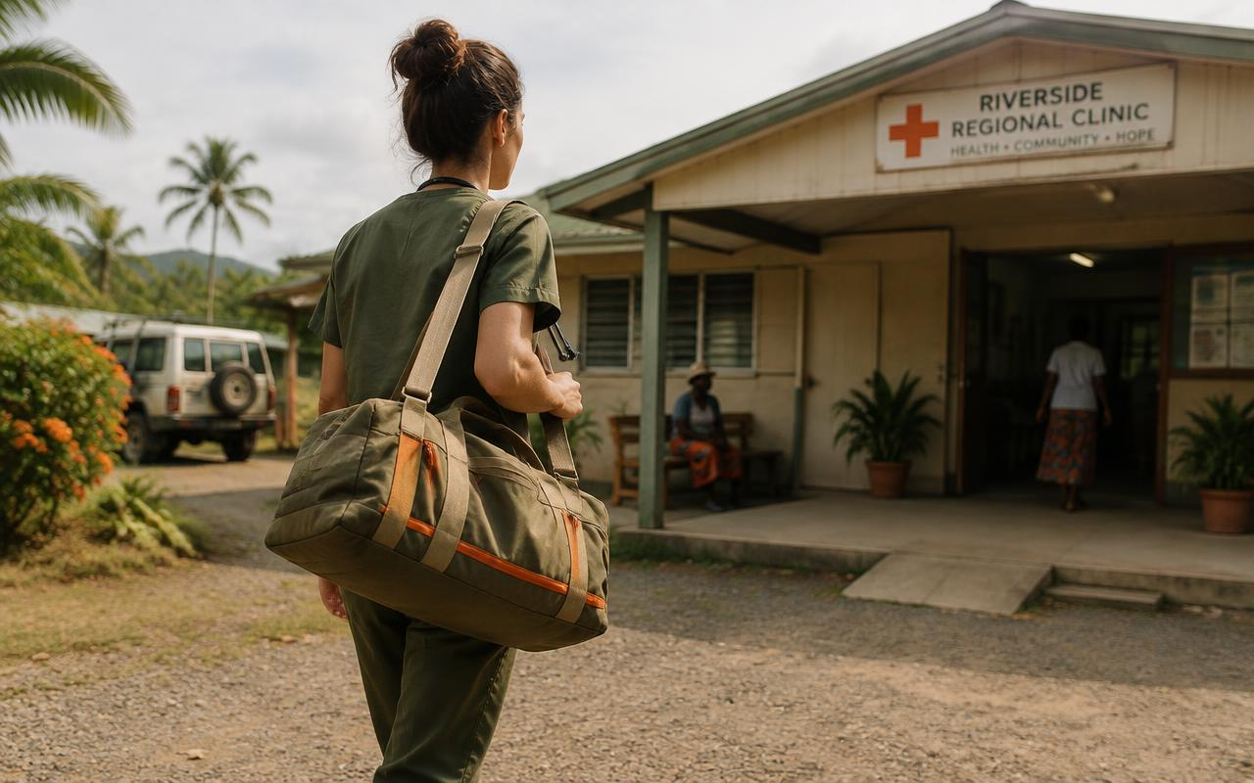
SAFETY | HEALTH | SUPPORT | PEACE OF MIND
FICTIONAL SAMPLE · VERIFY ALL DETAILS BEFORE TRAVEL

Emergency Contacts
Service | Phone Number | Notes
Uganda national emergency services | 999 or 112 | Request police, fire or medical assistance and give a landmark plus location pin. Dispatch and ambulance availability vary; test the NGO's alternative pathway without placing a test emergency call (verify before travel).
Police and local security escalation | 999 or 112; obtain the hotel and district police duty numbers | Ask the hotel and NGO to identify the relevant Kampala and Mbarara-area stations and save direct numbers (verify before travel).
Ambulance and medical evacuation dispatch | Save the NGO-contracted ambulance and insurer's 24-hour assistance numbers | Require confirmed coverage at the actual district hospital, an oxygen-capable vehicle when indicated, and a receiving-facility agreement; do not assume national dispatch provides a staffed ambulance (verify before travel).
US Embassy Kampala | +256 414 306 001 | 1577 Ggaba Road, Nsambya, Kampala. Request American Citizen Services or the after-hours duty officer for a US-citizen emergency; confirm current routing at ug.usembassy.gov (verify before travel).
Kampala major referral hospital | Mulago National Referral Hospital, Mulago Hill | Potential major referral option from the city centre; save its current emergency desk number through the official hospital directory. Confirm the correct unit and transport route rather than assuming walk-in specialty availability (verify before travel).
Mbarara referral and occupational PEP assessment | Mbarara Regional Referral Hospital, Mbarara city | Identify the casualty/emergency and HIV-service duty contacts through the NGO and hospital. Confirm 24-hour occupational exposure assessment, laboratory access and PEP stocks; the exact nearest capable facility depends on the district hospital's location (verify before travel).
Nursing registration authority | Uganda Nurses and Midwives Council — unmc.ug | Use the official council contact directory for temporary registration, qualification verification and scope questions. Save the named officer and written approval before deployment (verify before travel).

Nearest Hospital
Uganda national emergency services  999 or 112  Request police, fire or medical assistance and give a landmark plus location pin. Dispatch and ambulance availability vary; test the NGO's alternative pathway without placing a test emergency call (verify before travel).  - Arrange a travel-medicine consultation ideally 4–6 weeks before departure; select malaria prophylaxis based on contraindications and start and continue it on the prescribed schedule.  - Use DEET or picaridin repellent, long sleeves and treated clothing or nets; do not rely on prophylaxis alone.  - Seek same-day assessment for fever during travel and after return, explicitly mentioning Uganda travel; treat confusion, breathing difficulty, collapse or severe weakness as emergencies.  24/7 EMERGENCY ACCESS · CONFIRM ROUTE | 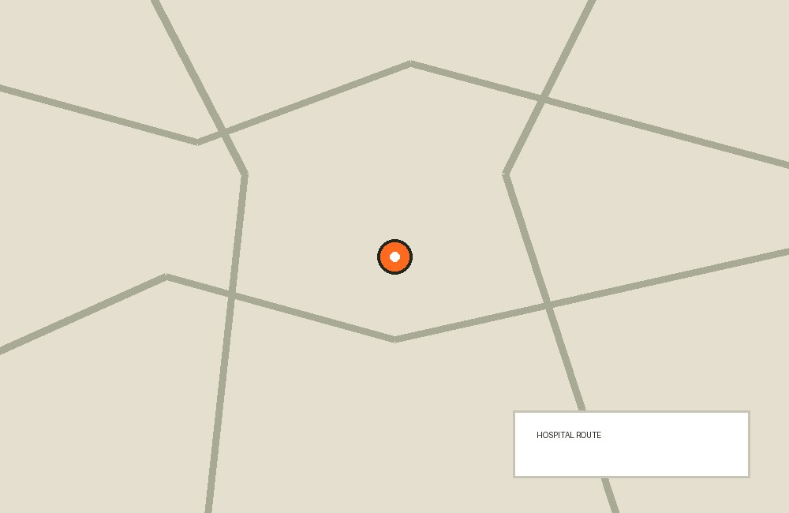

01 Destination Intelligence
Kampala and the Mbarara region require different movement and medical-support arrangements. November rain can slow both the intercity journey and the final rural approach.
- Review US State Department Uganda advice, embassy alerts, Uganda Ministry of Health notices and WHO outbreak updates shortly before departure and daily during deployment (verify before travel).
- Obtain the district hospital's exact name, district, GPS coordinates and access-road condition; do not treat 'near Mbarara' as a sufficient dispatch address.
- Plan for rain, standing water and reduced visibility; carry waterproof document protection, non-slip footwear and a spare clinical uniform.
- Avoid demonstrations, political gatherings and crowded incident scenes; ask the NGO for daily route and security advice rather than independently investigating disturbances.
- Keep phones, cash and bags discreet in central Kampala; use NGO-approved vehicles instead of motorcycle taxis or unvetted street transport.
- Review laws and social conditions affecting personal identity, medications, photography and clinical work; obtain confidential NGO advice where relevant (verify before travel).

02 Accommodation-Specific Guidance
A central Kampala hotel is suitable for arrival staging, not daily commuting to a rural hospital near Mbarara. Separate rural lodging must support sleep, secure equipment storage and rapid transport.
- Confirm the Kampala hotel's name and address, then map its access roads and nearest suitable emergency department with the NGO (verify before travel).
- Book NGO-vetted lodging near the district hospital for clinical days; reject any plan requiring daily Kampala–Mbarara commuting.
- Request controlled entry, a working room lock, backup power, reliable water, smoke alarms and an unobstructed stair exit; inspect these on arrival.
- Choose screened or air-conditioned rooms and use an insecticide-treated net where needed; use repellent even when sleeping in a hotel.
- Keep medicines and sharps in secure, temperature-appropriate storage inaccessible to housekeeping or visitors; arrange hospital storage for clinical supplies.
- Identify a hotel assembly point and a sheltered alternate pickup point; tell reception not to disclose your room number or deployment details.

03 Itinerary Risk Notes
The evening arrival and long transfer toward Mbarara are the principal movement concerns. The proposed clinical schedule needs time for orientation, rest and a safe return to Entebbe.
- Reconcile 2–9 November with 'Day 7 depart': Day 7 is 8 November and 9 November is Day 8; update flight, lodging, insurance and check-in records accordingly.
- Arrange a named driver and vehicle at Entebbe International Airport, with a pickup password and independent dispatch number; refuse unplanned substitutions until confirmed.
- Consider an airport-area overnight after the evening arrival; if continuing to central Kampala, use only a prearranged vetted transfer and never continue to Mbarara that night.
- Schedule the Kampala–Masaka–Mbarara road transfer in daylight, allowing a substantial traffic and rain buffer rather than a fixed arrival promise (verify before travel).
- Reserve the first hospital period for credential checks, orientation, referral pathways and infection-control assessment before accepting independent clinical duties.
- Return toward Entebbe at least the day before an early or time-critical international flight; avoid a rural-to-airport sprint or night drive to preserve clinical hours.

04 Emergency Protocols
Use a simple scene-safety, clinical-assessment and coordinated-response sequence. Local emergency numbers are useful backups, but the NGO must own a practical response pathway.
- Move out of immediate danger, assess airway, breathing and circulation within your training, and call 999 or 112 for life-threatening events.
- Send dispatch and the NGO a location pin, landmark, callback number, number of patients and a concise description of hazards or injuries.
- Activate the contracted ambulance or approved transport pathway simultaneously when national response is uncertain; do not self-drive when ill, injured or distressed.
- After a collision, prioritize traffic and fuel hazards, request police and medical help, and avoid roadside disputes; preserve essential information only when safe.
- During a security incident, shelter or withdraw as directed by the NGO, keep a low profile and contact the embassy for serious detention, violence or missing-person concerns.
- Carry an offline emergency card with allergies, medicines, insurer, NGO lead and next of kin; record incident times and actions without exposing patient identifiers.

05 Health & Medical Access
Malaria prevention and early assessment of fever are essential throughout this itinerary. Rural facilities may not have the diagnostics, blood products or critical care needed for a severely ill staff member.
- Arrange a travel-medicine consultation ideally 4–6 weeks before departure; select malaria prophylaxis based on contraindications and start and continue it on the prescribed schedule.
- Use DEET or picaridin repellent, long sleeves and treated clothing or nets; do not rely on prophylaxis alone.
- Seek same-day assessment for fever during travel and after return, explicitly mentioning Uganda travel; treat confusion, breathing difficulty, collapse or severe weakness as emergencies.
- Map district-level stabilization, Mbarara Regional Referral Hospital and a Kampala tertiary option; confirm emergency admission, laboratory, blood bank and critical-care capabilities (verify before travel).
- Use sealed or safely treated water, safe food practices and oral rehydration supplies; avoid freshwater swimming because of schistosomiasis risk.
- Arrange immediate wound washing and urgent rabies assessment after any mammal bite or scratch; identify a source of vaccine and immunoglobulin before rural deployment (verify before travel).

06 Evacuation Triggers & Routes
Evacuation decisions should be based on clinical capability and safe access, not on a predetermined destination alone. All receiving facilities, road routes and aviation options require operational confirmation.
- Request urgent medical evacuation assessment for severe trauma, suspected severe malaria, respiratory compromise, altered consciousness or any illness beyond local stabilization capability.
- Trigger precautionary relocation for credible targeted threats, unrest affecting access, road isolation or loss of essential medical support; let the NGO security lead authorize safe timing.
- Use the district hospital to Mbarara referral pathway when clinically appropriate, then consider Kampala tertiary care; pre-alert the receiving team and document acceptance (verify before travel).
- Plan the Mbarara–Masaka–Kampala/Entebbe corridor for road transfer, but recheck road conditions and alternate access before movement; do not use flooded or unassessed rural shortcuts.
- Treat Entebbe International Airport as the principal international exit; consider Mbarara/Nyakisharara airfield only if the evacuation provider confirms aircraft suitability, access and permissions (verify before travel).
- Let the treating clinician and assistance provider select road ambulance, air ambulance or commercial travel; do not delay life-saving care for authorization, and never assume an unstable patient can fly commercially.

07 Financial & Document Continuity
Keep personal travel documents and deployment records recoverable without carrying all originals together. Insurance must cover clinical work rather than tourism alone.
- Check passport validity, Uganda entry authorization and yellow-fever certificate requirements using official immigration and embassy sources; use the official Uganda e-immigration portal where applicable (verify before travel).
- Obtain written insurance confirmation for paid or volunteer nursing, occupational infection, hospitalization, medical evacuation and repatriation, including exclusions for outbreaks or advisory levels.
- Carry two payment methods stored separately and a modest reserve of Ugandan shillings; agree who can guarantee hospital deposits after hours.
- Store encrypted copies of passport, registration, insurance and emergency contacts offline and with an authorized home contact; carry paper copies separately from originals.
- Keep deployment authorization and medication paperwork accessible at the border without placing confidential patient or staff records in the same folder.
- Record card-blocking numbers and the embassy lost-passport procedure; establish emergency funding authority with the NGO before departure.

08 Communications Plan
The mission needs a named duty officer, predictable check-ins and a tested missed-contact response. Rural connectivity should be assessed before it becomes an emergency dependency.
- Nominate an NGO in-country lead, alternate, clinical supervisor and US-based contact; give each the confirmed itinerary and emergency escalation tree.
- Check in on arrival, at every intercity departure and arrival, and morning and evening during rural deployment; use Uganda's East Africa Time, UTC+3.
- Agree a missed-check-in ladder: attempt phone and messaging contact after 30 minutes, notify the duty officer after 60 minutes, and initiate local welfare checks after two hours or sooner for danger indicators.
- Obtain a legally registered local SIM or compatible roaming service, and carry a charged power bank; download offline maps and test coverage at the hospital and lodging.
- Set an alternate voice or SMS channel if messaging data fails; arrange a vehicle radio or lawful satellite backup if the rural site lacks dependable coverage (verify before travel).
- Enroll in the US Smart Traveler Enrollment Program and prohibit identifiable patient details in personal messages, social posts or routine location check-ins.

09 Credentials & Licensing for Practice Abroad
A US RN license does not by itself authorize nursing practice in Uganda. Temporary registration, local privileges and insurance must be resolved before patient care begins.
- Apply to the Uganda Nurses and Midwives Council for the appropriate temporary registration; confirm current eligibility, processing time, fees and required source verification directly with the council (verify before travel).
- Carry your passport, current US RN license verification, nursing qualification, good-standing documentation, CV, NGO appointment letter and host-facility acceptance; obtain certified copies if requested.
- Save a named UNMC registration contact and your US state board's verification contact; have the host hospital independently verify approval before assigning clinical duties.
- Obtain a written role description and privileges covering assessment, medication administration and procedures; do not assume suturing or prescribing is permitted because you carry a suture kit or antibiotics.
- Confirm malpractice or professional indemnity coverage valid in Uganda for the actual rural setting, procedures and dates, including legal defense and occupational incidents.
- Confirm the correct immigration permission for clinical or volunteer work and any other authorization with the NGO; restrict activities to expressly authorized nonclinical support if approval is delayed (verify before travel).

10 Medical Kit & Pharmaceutical Customs
The declared kit comprises a suture kit, PPE, amoxicillin, 20 tramadol tablets, a glucometer and a 28-day HIV PEP supply. Personal medication and clinical supplies may follow different import pathways.
- Create an inventory listing quantities, generic names, strengths, expiry dates and intended users for every item; add glucometer strips, batteries, lancets and sharps disposal arrangements.
- Seek written guidance from Uganda's National Drug Authority and customs on tramadol's current control status and required import permission; do not assume 20 tablets are exempt, and check transit-country rules (verify before travel).
- Carry prescriptions and a clinician or NGO letter stating indication, dose, duration and purpose; keep tramadol, amoxicillin and PEP in original labeled packaging.
- Separate personal emergency PEP from medicines intended for patients; use an approved NGO import or donation pathway for clinical stock and make required declarations (verify before travel).
- Keep medicines secure and within labeled temperature and humidity limits; use lockable storage and inventory controls for tramadol, with no informal sharing or donation.
- Confirm airline rules for the suture kit, needles, lancets and batteries; retain essential lawful medicines in carry-on luggage and pack sharps in compliant secure containers (verify before travel).

11 Occupational Exposure & Post-Exposure Protocols
Sharps, blood exposure and TB wards are identified hazards; a personal 28-day HIV PEP supply is useful only with an immediate assessment and follow-up pathway. The exact district location is needed to identify the nearest capable exposure service.
- Wash sharps injuries promptly with soap and water and flush exposed eyes or mucosa with water or saline; do not squeeze wounds, scrub aggressively or apply bleach.
- Report immediately to the host supervisor and NGO clinician, document the exposure, and obtain consent-based source testing and baseline HIV, HBV and HCV assessment under local protocol.
- Start indicated HIV PEP as soon as possible, ideally within hours and no later than 72 hours; do not wait for source results, and obtain expert advice urgently even if presentation is later.
- Have an occupational-health clinician verify the carried PEP regimen, expiry, interactions and monitoring plan; complete the prescribed 28-day course and arrange follow-up testing under current guidance.
- Confirm 24-hour exposure assessment at the host facility and a backup at Mbarara Regional Referral Hospital; arrange HBV management according to documented immunity and HCV testing because no HCV PEP is available (verify before travel).
- Use a fit-tested N95/FFP2 or equivalent for TB-risk work, maximize ventilation and avoid unsupported aerosol-generating procedures; report a significant TB exposure and arrange repeat testing 8–10 weeks after the last exposure as advised.
- Stop unsupported high-risk care if PPE, isolation or outbreak protocols are inadequate; isolate safely, notify infection prevention and follow Uganda Ministry of Health directions for suspected outbreak illness rather than taking routine public transport.

12 Clinical Deployment Continuity
Continuity depends on local ownership, documented handoffs and rested staff. This section governs service transfer when the medical or security evacuation thresholds elsewhere in this plan are met.
- Name a host-facility clinical lead and alternate who retain patient responsibility; agree daily task allocation, supervision and escalation before the first shift.
- Prepare a secure handoff template covering patient status, pending tests, time-critical medicines, procedures and referral needs; keep records within approved facility systems.
- Activate handoff when relocation is ordered, illness makes you unfit, registration lapses or safe supervision disappears; do not remain in unsafe conditions solely to finish a shift.
- Transfer medicine inventories, keys, sharps responsibilities and outstanding referrals to a named authorized colleague; document receipt without removing patient files.
- Set shift limits, protected sleep, meal and hydration breaks; avoid overnight duty followed by a long road transfer and use a buddy to identify fatigue-related errors.
- Hold a brief daily welfare and workload review, offer confidential support after distressing events, and schedule an end-of-mission debrief and occupational-health follow-up.

13 Vaccination & Immunity Readiness
You report hepatitis B immunity, a negative IGRA in 2026 and completed yellow-fever vaccination, but the separate answer 'None' creates uncertainty. Confirm these records rather than interpreting 'None' as proof of no further vaccination needs.
- Reconcile the shifted questionnaire entries with occupational health and confirm allergies, current medicines, chronic conditions and any contraindications relevant to prophylaxis or vaccines.
- Carry the original International Certificate of Vaccination or Prophylaxis for yellow fever and confirm that the entry is valid; verify current entry rules rather than assuming a booster is required (verify before travel).
- Provide hepatitis B vaccination and documented anti-HBs response to the NGO clinician; clarify any missing evidence before sharps-risk duties.
- Review routine MMR, tetanus/diphtheria/pertussis, polio, influenza and COVID-19 protection, plus hepatitis A and typhoid recommendations for Uganda (verify before travel).
- Discuss rabies pre-exposure vaccination and any current polio or outbreak-related recommendations based on rural access and duty location; reserve other vaccines for a clinician-assessed indication.
- Retain the dated 2026 IGRA result as a TB baseline; do not treat a negative result as protection, and arrange exposure-based or symptom-driven follow-up.

Pre-departure Checklist
Documents & Essentials
☐ Confirm whether departure is 8 or 9 November and align all bookings and coverage.
☐ Verify immigration permission for clinical work and carry credential and appointment documents.
☐ Confirm Uganda-valid malpractice, occupational exposure and evacuation coverage in writing.
☐ Obtain required drug-import documentation and written tramadol guidance from relevant authorities.
☐ Agree check-in times, missed-contact thresholds and a named 24-hour NGO duty officer.
☐ Prepare encrypted and paper document backups, separate payment methods and emergency funding authority.
Health & Safety
☐ Obtain the district hospital's name, GPS location, supervisor and rural lodging address.
☐ Complete a travel-medicine consultation and obtain malaria prophylaxis.
☐ Reconcile vaccination answers and carry yellow-fever, hepatitis B immunity and baseline IGRA records.
☐ Have the 28-day PEP regimen reviewed and establish immediate exposure reporting and follow-up.
☐ Confirm hospital acceptance pathways, ambulance dispatch and insurer assistance numbers.
Travel Readiness
☐ Secure UNMC temporary registration and written clinical privileges before patient care.
☐ Inventory the suture kit, PPE, amoxicillin, 20 tramadol tablets, glucometer and PEP with strengths and expiry dates.
☐ Complete respirator fit testing and confirm adequate PPE, sharps containers and TB controls.
☐ Book vetted airport transfers, daylight intercity travel and a pre-flight buffer night.
☐ Review current security, weather, outbreak and entry information immediately before departure (verify before travel).
◇ Be informed. Be prepared. Travel with confidence.
This sample complements official advisories and insurance. Verify critical details before travel.
PRINT THIS PAGE · CUT AROUND THE OUTER LINE · FOLD AT CENTER
SERLOCK TRAVEL · QUICK REFERENCE  Uganda  October 3–17 · Fictional sample · Clinical team  EMERGENCY & SUPPORT  Emergency services  112 or 999 · verify locally  U.S. Embassy Kampala  +256 414 306 001  Referral hospital  Mulago Hospital · verify emergency desk  Exposure / PEP contact  NGO clinical lead · fictional  All details are fictional examples. Verify every number and route before travel. | TRIP DETAILS · CARRY OFFLINE  TRAVELERS  Clinical deployment team · fictional travelers  ACCOMMODATION  Kampala guesthouse · fictional booking  PERSONAL CONTACT  Write in: ______________________________  INSURANCE / ASSISTANCE  Provider: ______________________________  Policy: _________________________________  Phone: _________________________________  BEFORE CARRYING  Verify all phone numbers, addresses, coverage details and routes. This card complements official advisories and insurance.

