SERLOCK TRAVEL · BUSINESS TEAM SAMPLE
Readiness Plan —
Lagos

TRAVEL PREPARED. TRAVEL FURTHER.

SAFETY | HEALTH | SUPPORT | PEACE OF MIND
FICTIONAL SAMPLE · VERIFY ALL DETAILS BEFORE TRAVEL

Emergency Contacts
Service | Phone Number | Notes
All emergencies | 112 | Nigeria national emergency number; confirm response arrangements locally.
Nigeria Police emergency | 112 / local command | Use 112 first and the contracted security provider for coordinated support.
Aga Khan? Not in Lagos | Do not use | Avoid copied destination errors; confirm a Lagos receiving hospital before travel.
Evercare Hospital Lekki | +234 1 700 0000 | Private hospital; verify emergency capability, route, and insurer acceptance.
U.S. Consulate General Lagos | +234 201 460 3400 | Confirm current citizen-services and after-hours details before travel.
Company incident lead | Sam Patel — internal directory | First organizational escalation contact.
Security lead | Kim Ode — internal directory | Owns security assessment, movement controls, and relocation advice.
Insurer assistance | International SOS — policy card | Use the verified membership number and 24/7 line stored offline.

Nearest Hospital
Aga Khan? Not in Lagos  Do not use  Avoid copied destination errors; confirm a Lagos receiving hospital before travel.  24/7 EMERGENCY ACCESS · CONFIRM ROUTE | 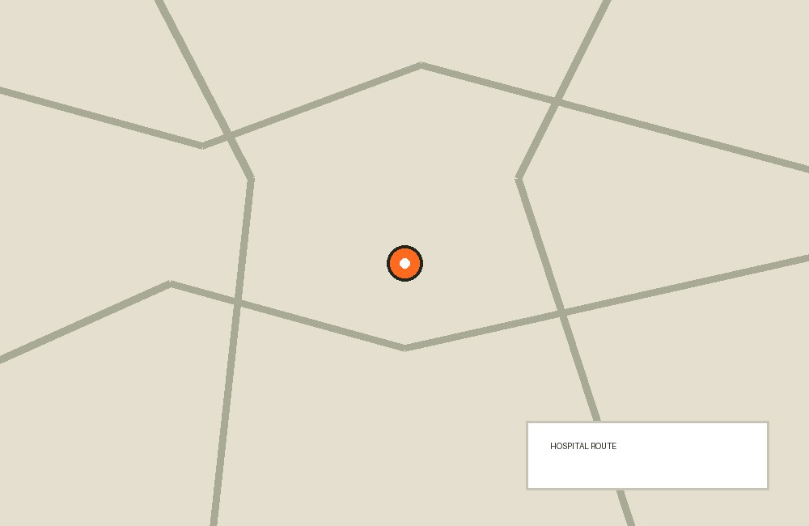

01 Destination Intelligence
Lagos conditions can change by district and hour; decisions should use current local security and transport information.
- Review official travel advice, company intelligence, weather, flooding, and civil-disturbance alerts before departure and daily.
- Map airport, hotel, meeting sites, approved hospitals, police support, and two alternate routes with the security provider.
- Avoid demonstrations, political gatherings, waterfront or isolated areas not approved for work, and unnecessary night movement.
- Build substantial transfer buffers because traffic or flooding can block otherwise short routes.
- Use only organization-approved venues and transport; do not publish real-time itineraries or accommodation details.

02 Duty-of-Care Summary & Documentation
Acme Energy must document foreseeable risks, controls, ownership, and traveler acceptance throughout the assignment.
- Record the trip owner, approving manager, traveler, security provider, insurer, and 24/7 incident lead in one controlled file.
- Issue a current risk assessment covering movement, accommodation, health, information security, and evacuation thresholds.
- Document the traveler briefing, questions, medical self-declaration process, consent, and acknowledgement of remaining risks.
- Confirm insurance and assistance coverage for Nigeria, business activity, medical evacuation, security evacuation, and trip extension.
- Retain booking changes, check-in records, incident decisions, and post-trip actions according to company privacy and retention rules.

03 Arrival, Accommodation & Movement Control
The airport-to-hotel movement and daily road transfers need positive driver and route control.
- Use a prearranged driver whose name, photo, phone, vehicle plate, and pickup password are confirmed through dispatch.
- Reject substitutions until dispatch independently verifies them; do not accept unsolicited airport transport.
- Require a staffed hotel with controlled entry, reliable locks, fire detection, backup power, potable water, and a tested emergency procedure.
- Share departure, route, vehicle, and estimated arrival in the company channel for every movement.
- Avoid routine night travel and keep doors locked, windows closed, phones out of sight, and bags off visible seats.

04 Itinerary Risk Notes
Meetings should remain movable, cancelable, and supportable without exposing the traveler to schedule pressure.
- Schedule meetings during daylight at approved sites with controlled access and reliable communications.
- Allow a minimum traffic contingency agreed by local operations rather than relying on map estimates.
- Do not disclose the complete itinerary to drivers, vendors, or contacts who need only one movement segment.
- Pause movement when routes are blocked, drivers cannot be verified, security alerts affect the destination, or the traveler loses communications.
- Keep one daily work block available for delay recovery so a missed meeting does not force unsafe movement.

05 Escalation Matrix
Escalation is ordered but not sequential when danger is immediate.* - For immediate danger, call 112 and the security provider, then notify Sam Patel as soon as safe. - For a missed check-in, the travel owner calls and messages at 15 minutes, contacts the driver and hotel at 30 minutes, and alerts Kim Ode at 60 minutes. - For medical concerns, contact the assistance provider and approved clinic; call emergency services first for life-threatening symptoms. - For device loss or suspected compromise, disconnect the device, notify the security operations contact immediately, and begin remote lock and credential revocation. - Kim Ode owns security relocation recommendations; Sam Patel owns business continuity and family notification; HR supports welfare and records. 06 Check-In Schedule *Twice-daily check-ins provide a reliable welfare signal without requiring continuous surveillance.
- Check in before the first movement and after returning to the hotel each day through the approved Teams channel.
- Include status, next destination, driver or vehicle reference, expected arrival, and any change in risk.
- Use SMS or voice to the travel owner if Teams fails, then contact security through the offline number.
- Never mark the traveler safe based only on device location; require direct voice or message confirmation.
- Log exceptions and close each escalation explicitly so unresolved alerts do not carry into the next movement.

06 Emergency & Medical Protocols
Rapid stabilization and organized communication take priority over insurer or management reporting.
- Call 112 for serious injury, chest pain, breathing difficulty, collapse, major bleeding, or immediate threat.
- Send the security provider a precise location pin, landmark, callback number, and short situation report.
- Carry diabetes details and metformin in original packaging; maintain food, hydration, and dosing routines during delays.
- Confirm Evercare or another approved receiving hospital with the assistance provider before travel; let emergency clinicians choose in a crisis.
- Keep medical details private and share only what responders, the assistance provider, or authorized duty-of-care staff need.

07 Device & Data Security
The traveler should carry the minimum data necessary and assume devices may be lost, inspected, or observed.
- Use a company-managed travel laptop with BitLocker, current patches, MDM, endpoint protection, and an approved VPN.
- Move confidential contract data to controlled remote access where possible and remove unrelated client files before departure.
- Use a privacy screen, disable automatic Wi-Fi and Bluetooth discovery, and never use unknown charging cables or public USB ports.
- Keep the laptop and phone in hand luggage and out of sight during road movement; do not leave either in a meeting room or vehicle.
- After loss or inspection outside policy, report immediately, isolate accounts, rotate credentials, preserve facts, and follow the incident-response playbook.

08 Business Continuity
The trip must be able to pause or move online without a single traveler, device, or meeting becoming a critical dependency.
- Assign a home-office deputy with access to current documents, decisions, and client contacts.
- Store essential work in approved shared systems with least-privilege access rather than only on the travel laptop.
- Prepare remote-meeting links and an alternate time window for every critical appointment.
- Define which decisions the traveler may make offline and which require home-office approval.
- If travel is disrupted, prioritize traveler welfare, notify clients with minimal security detail, and transfer work to the deputy.

09 Financial & Document Continuity
Independent payment and document recovery prevent a single loss from stopping movement or care.
- Carry two corporate or personal payment methods separately and a modest local-currency reserve approved by policy.
- Store encrypted copies of passport, visa, insurance, itinerary, invitation, and emergency contacts offline and with the travel owner.
- Confirm who can approve emergency hotel nights, replacement transport, medical deposits, or evacuation costs after hours.
- Use bank-affiliated ATMs in controlled locations and avoid displaying cash or cards.
- After theft, move to safety, freeze cards and devices, obtain reports when appropriate, and notify finance and security.

10 Evacuation, Relocation & Shelter Triggers
Pre-agreed thresholds keep commercial pressure from delaying a safety decision.
- Shelter at the approved hotel when movement routes are temporarily unsafe and the building remains secure and supplied.
- Relocate to the alternate approved hotel when access control, utilities, nearby unrest, or medical support falls below the agreed minimum.
- Suspend meetings after a credible threat, route interdiction, official curfew, loss of vetted transport, or sustained communications failure.
- Begin departure planning when official advice worsens, the provider recommends evacuation, medical needs exceed local capability, or commercial flights may close.
- Kim Ode records the recommendation, Sam Patel authorizes business impacts, and the assistance provider coordinates transport; emergency action does not wait for paperwork.

11 Incident Reporting & Post-Trip Review
Accurate, minimal reporting supports care, legal obligations, and improvement without spreading sensitive data.
- Record time, location, people involved, actions, provider references, and current status as soon as safe.
- Use the company incident channel, not personal email or public messaging, for confidential details.
- Preserve original evidence without confronting subjects or taking unsafe photographs.
- Complete welfare, medical, security, privacy, and insurance reports required by the event.
- Hold a post-trip review within five working days and assign owners and deadlines for corrective actions.

12 Departure & Recovery
Departure planning begins before the final meeting and remains flexible to operational conditions.
- Reconfirm flight, terminal, route, driver, and airport timing the day before departure.
- Move nonessential meetings online if they threaten the protected airport transfer window.
- Check in before hotel departure, at airport arrival, after security, and on arrival home.
- Report delayed health symptoms and disclose recent Nigeria travel to clinicians when relevant.
- Return travel devices for security review before reconnecting them to sensitive company systems if policy requires.

Pre-departure Checklist
Documents & Essentials
☐ Verify passport, visa, invitation, and Nigeria entry requirements.
☐ Confirm insurance and assistance coverage, membership number, and evacuation benefits.
☐ Validate Sam Patel, Kim Ode, HR, security provider, insurer, hotel, driver dispatch, embassy, and hospital contacts.
☐ Split payment methods, local cash, and document copies.
Health & Safety
☐ Pack diabetes medication and medical summary in cabin baggage.
☐ Save approved routes, alternate hotel, airport, and hospital offline.
Travel Readiness
☐ Approve the trip risk assessment and record traveler briefing and consent.
☐ Book approved hotel and vetted airport and daily transport.
☐ Test twice-daily Teams check-ins and SMS/voice fallback.
☐ Brief the 15-, 30-, and 60-minute missed-check-in escalation.
☐ Prepare the managed travel laptop, VPN, MDM, encryption, privacy screen, and remote-lock process.
☐ Remove unnecessary confidential data and confirm the home-office deputy can access required work.
☐ Confirm remote-meeting fallbacks and client communication language.
☐ Review relocation, suspension, and departure triggers with decision owners.
☐ Check security, weather, and transport alerts 48 hours before departure.
☐ Schedule the post-trip welfare and security review.
◇ Be informed. Be prepared. Travel with confidence.
This sample complements official advisories and insurance. Verify critical details before travel.
PRINT THIS PAGE · CUT AROUND THE OUTER LINE · FOLD AT CENTER
SERLOCK TRAVEL · QUICK REFERENCE  Lagos  September 14–20 · Fictional sample · Business team  EMERGENCY & SUPPORT  Emergency services  112 · verify locally  Corporate travel desk  Fictional · +1 312 555 0400  U.S. Consulate Lagos  Verify current official number  Hospital  Evercare Hospital · +234 1 700 0000  All details are fictional examples. Verify every number and route before travel. | TRIP DETAILS · CARRY OFFLINE  TRAVELERS  Meridian project team · fictional travelers  ACCOMMODATION  Victoria Island hotel · fictional booking  PERSONAL CONTACT  Write in: ______________________________  INSURANCE / ASSISTANCE  Provider: ______________________________  Policy: _________________________________  Phone: _________________________________  BEFORE CARRYING  Verify all phone numbers, addresses, coverage details and routes. This card complements official advisories and insurance.

